Tasks

- Find the IP address of the computer you are currently using.

Command: ipconfig
IP Address: 192.168.56.1
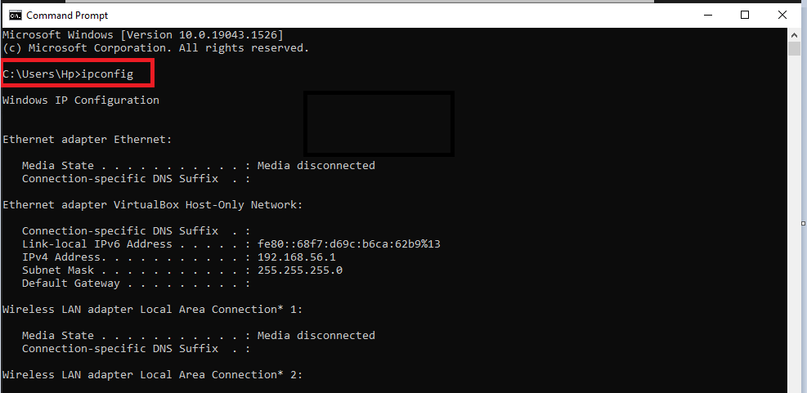

- Find the IP address of the computer you are currently using, plus MAC address, the gateway, plus whether DHCP is turned on.

Command:
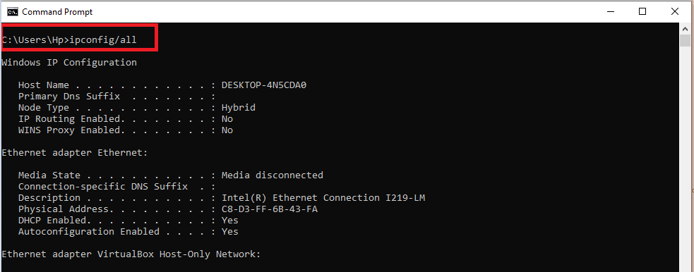

Answer:
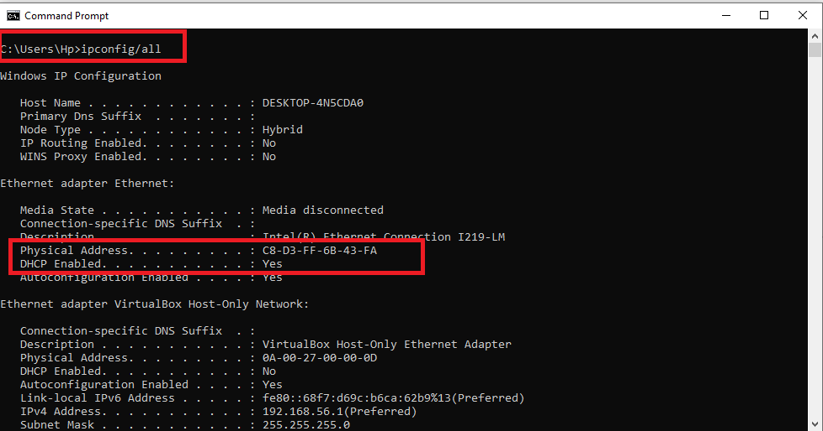

- Display the host name of the computer.

Command:
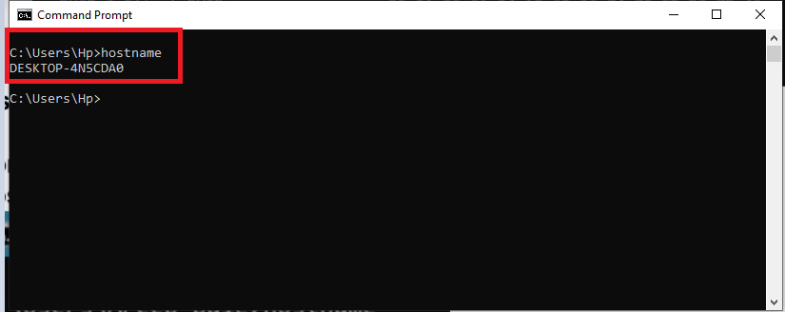

- Check for basic IP connectivity between two computers by name and IP address. How can basic IP connectivity be checked? What are the reasons why there is no connectivity?

Command: ping <hostname or ip address>
Reasons of no-connectivity: If the ping is not working or ping request time out. Reasons for request time out or destination host unreachable:
- When Firewall incoming connections are blocked.
- When Windows firewall does not allow File and Printer Sharing app.
- When Echo is disabled
- When IP address of host or destination is not found.

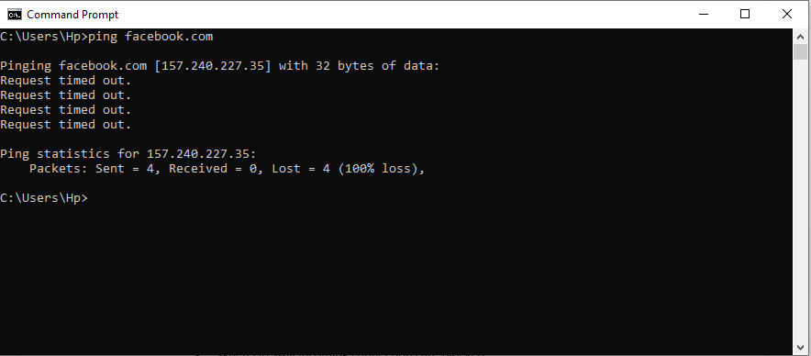

- Find out which ports on your host are connected to applications. Connect the browser to some external web page before running the appropriate command.

Command:
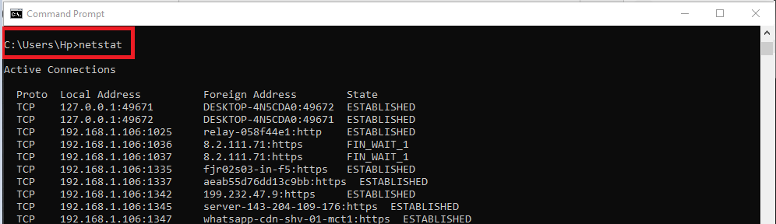

Answer:
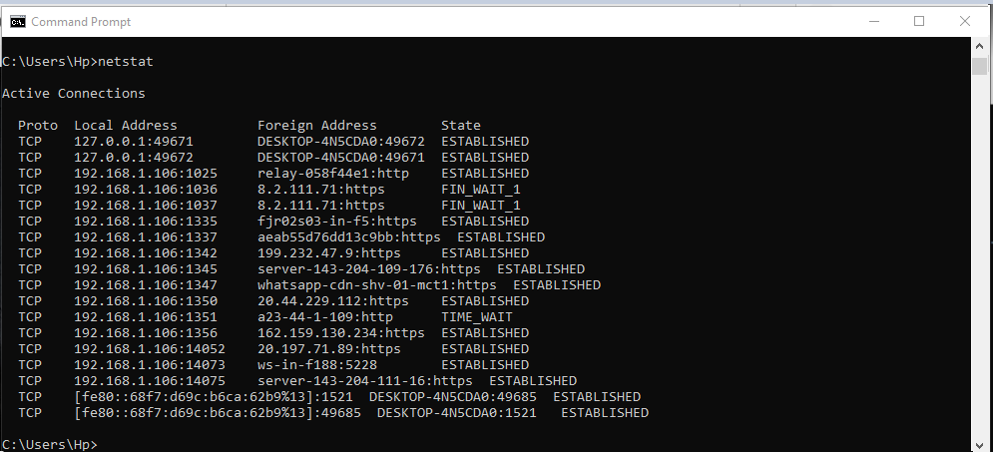

- Find the path of routers to www.google.com.What is its IP address? How many hops involved in the path?

Command:
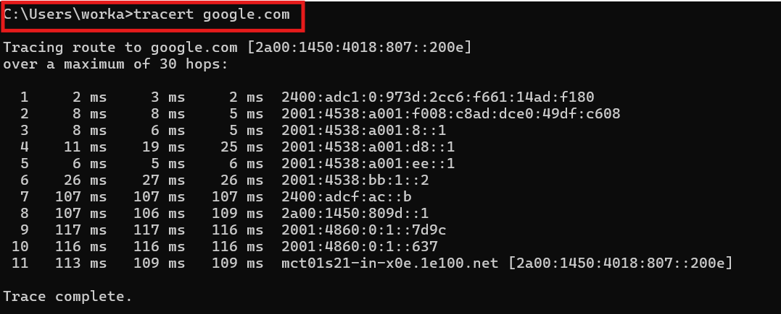

Answer:

- A ping to 192.168.0.2 works but a ping to the machine’s name “blue machine” fails. What could be wrong?
Reason:
It’s because the system’s DNS record doesn’t have any Type A mapping for machine “blue_machine” or the DNS server may not be functioning.
- Which type of cable will you use to connect in a normal home installation?
Answer:

The most commonly used cable in home installation is UTP (Unshielded Twisted Pair) that consists 4 twisted pairs of wires. Standard connector for UTP cabling is an RJ-45 connector. They are most commonly used because they are least expensive compared to Fiber Optics etc. They are copper based-medium wire.

- Can you connect a Switch to another Switch or a router to a PC using a straight- through cable? Explain your answer.

Answer:

To connect different devices, we can use straight through cable is used in local networks so a router can be connected to switch using straight through wire but a switch to switch cannot be connected.

- Write a brief report on your home network or any organizational network including topology, 1 page max).

Answer:

At my home, we’ve a Wi-Fi network and that’s the access network we use to access the internet with different end points on the network making it a start like structure and it is provided to us by our local ISP (StormFibre) which then connects to another ISP’s and make network of networks. Wi-Fi devices use a multi-layer switch that combines 2, 3, 4 switching technologies and provides a high-speed scalability with low latency.

WIFI network works on STAR topology and that’s also one of the most common topology that is used in business networks and home networks. Its popularity is because of its connectivity with the Ethernet which is again quite popular which is kind of a communication protocol Token Ring like other than the fact that the Ethernet operates on cable networks using a star topology.

One another major reason for using WIFI instead of cable LANs is because LAN has a limitation of 4 switch ports (depending upon the brands) and any topology where all devices in the networks are connected to a central hub can be considered as Star Network Topology.

